**Issues:**   
1. When we are running the application on localhost and this error comes:

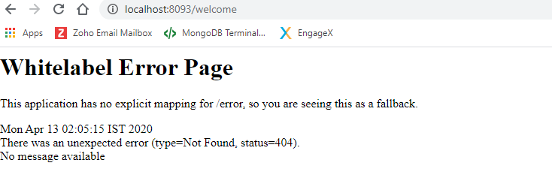  
Solution:

1.Go to the console window of the eclipse and there will error written after this line starting with “Resolved” keyword that will be an error. Mostly this type of error comes when we have not included some kind of maven dependency in pom file.  


2. Bootstrap class DemoApplication.java should know the package or the class path where it should refer in order access the controller. Hence you need to specify @ComponentScan(basePackages= {"com.example"} on top of your Bootstrap class.   
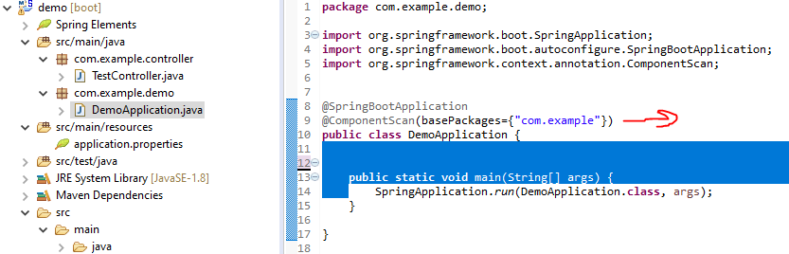

**2. When we are doing maven install on right click of the pom file then the following error comes:**  
**“**[No compiler is provided in this environment. Perhaps you are running on a JRE rather than a JDK?](https://stackoverflow.com/questions/19655184/no-compiler-is-provided-in-this-environment-perhaps-you-are-running-on-a-jre-ra)**”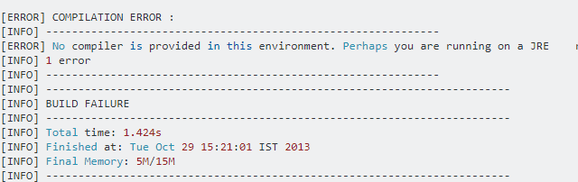 Solution:**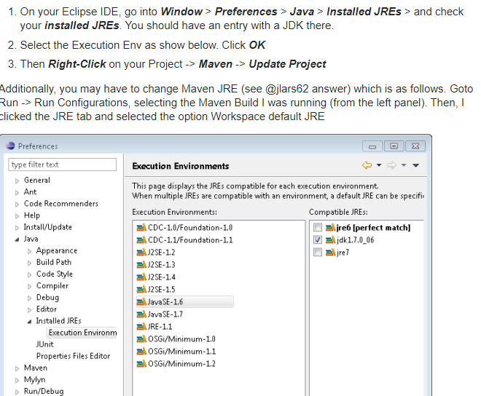3. This error comes in console when we are running the spring boot application.  
“[Web server failed to start. Port 8080 was already in use. Spring Boot](https://stackoverflow.com/questions/56499928/web-server-failed-to-start-port-8080-was-already-in-use-spring-boot)”  
**Solution:**1) Open **cmd**

2) Run following commands  
For all listening ports- **netstat -aon | find /i "listening" ( this will show all ports running)**

Apply port filter- **netstat -aon |find /i "listening" |find "8080" ( this will show only 8080 specific port)**

Finally with the PID we can run the following command to kill the process  
  
*3) Copy PID from result set-*

Ex: taskkill /F /PID 13340 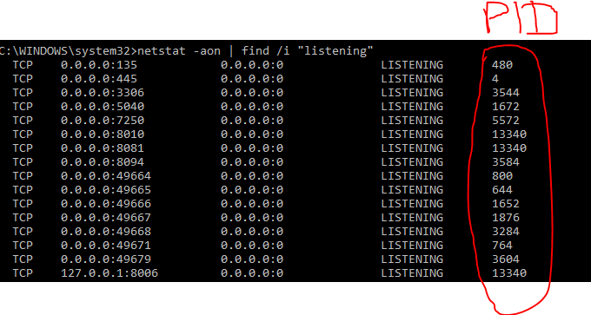

**Steps to run the Spring Boot application:**  
1. Right click on project -🡪 Maven -🡪 Update project.  
2. Right click on pom file🡪 Run as 🡪 maven clean-🡪 maven install   
3. Right click on the DemoApplication.java (class containing the main method) 🡪 Run as ”Java Application”  
  
4. Open chrome and type🡪 <http://localhost:8094/welcome> (type welcome as page name in request mapping inside the controller class)